Introduction to Networking Assignment

Draw a simple diagram (hand-drawn or digital) showing how your phone connects to Instagram, including your device, WiFi router, ISP, and Instagram server. Label each part and the connections.
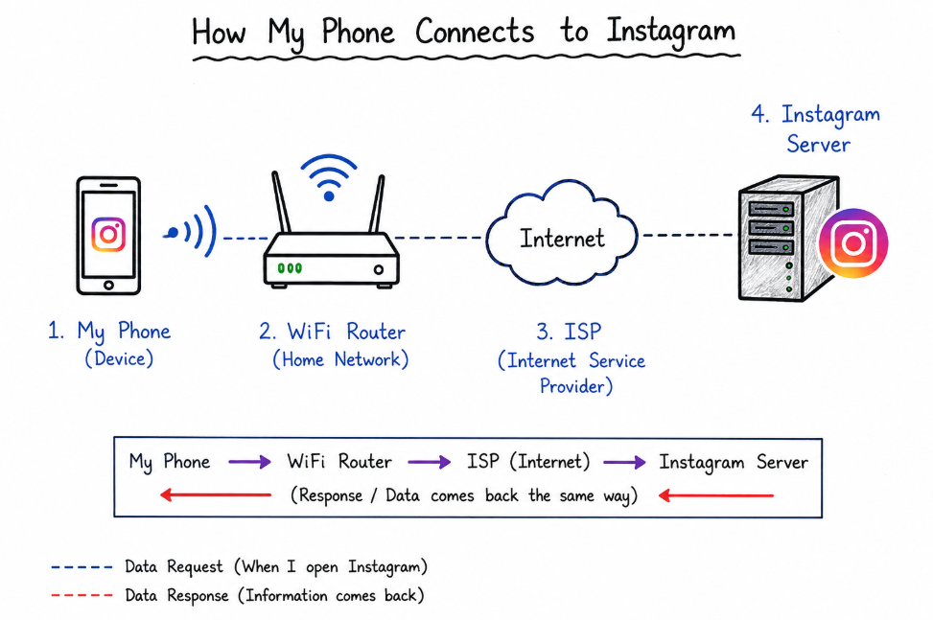

2. List 5 devices you use or see daily that are part of a network (for example: smartphone, smart TV, WiFi router, laptop, smartwatch). For each, write what type of network it connects to (LAN, WAN, PAN, etc.).

5 Devices Used Daily and Their Network Types
Device | Network Type | Easy Explanation
Smartphone | WAN / LAN | Connects to the Internet using mobile data or WiFi.
Laptop | LAN / WAN | Connects to a WiFi network and the Internet.
WiFi Router | LAN / WAN | Connects devices in the home and provides Internet access.
Smart TV | LAN / WAN | Uses WiFi to stream videos from the Internet.
Smartwatch | PAN | Connects to a smartphone using Bluetooth.
Network Types:
- LAN (Local Area Network): Network inside a home, school, or office.
- WAN (Wide Area Network): Large network like the Internet.
- PAN (Personal Area Network): Small network around one person, such as Bluetooth connections.

3. Internet vs Intranet
Difference Between Internet and Intranet
Internet:
The Internet is a public network that anyone can use. For example, when I connect to public WiFi and open Google, YouTube, or Instagram, I am using the Internet.
Intranet:
An intranet is a private network used only by a specific organization. For example, my college may have a student portal where only students and teachers can log in to check attendance, notes, or results.
In Simple Words:
- Internet = Open for everyone
- Intranet = Private network for a specific group of people

4. Pick any one app you use (like WhatsApp, Zomato, or Flipkart) and describe, in 4-5 lines, how data travels from your device to their server and back when you perform a search inside the app.
When I search for a contact in WhatsApp, my phone sends the search request through WiFi or mobile data. The request goes to the WiFi router and then to the Internet. After that, it reaches the WhatsApp server, which processes the request and finds the required information. The server sends the result back through the Internet and router to my phone. Finally, WhatsApp displays the search result on my screen.

